**­­­­­­­ MINOR PROJECT REPORT**

**MATCH MY MANSION**

SUBMITTED IN THE PARTIAL FULFILLMENT OF THE

REQUIREMENTS FOR THE AWARD OF

MINOR PROJECT



**Under the Guidance of :**

Dr. Navtej Singh Ghumman

**Submitted By:**

|  |  |
| --- | --- |
| **Name** | **Roll no.** |
| Ranveer Kumar | 211477 |
| Prabhnoor Kaur | 211468 |
| Vnashita | 211497 |
| Rishikesh Gautam | 211479 |

**Shaheed Bhagat Singh State University, Ferozepur, Punjab**

**CANDIDATE’S DECLARATION**

We, Ranveer Kumar, Prabhnoor Kaur, Vanshita & Rishikesh Gautam hereby declare that the project titled “MATCH MY MANSION” in partial fulfillment of requirements for the award of degree of B.TECH submitted in the “Department of CSE” at “Shaheed Bhagat Singh State University, Ferozepur” is an authentic reward of our original work. This project was carried out under the guidance of Dr. Navtej Singh Ghumman.

We, confirm that the work in this project report is original and was done by us. This project has not been submitted to any other institution for any degree or certification. All the information and data presented are real and were collected through our own efforts. We have followed all the rules and guidelines provided by Shaheed Bhagat Singh State University, Ferozepur while working on this project.

We grateful to our mentor Dr. Navtej Singh Ghumman, for their support and guidance throughout the project.

Signature of the Students

1. _________________________
2. _________________________
3. _________________________
4. _________________________

This is to certify that the above statement made by the candidates is correct to the best of my own knowledge.

Signature of the Mentor

_______________________

**INDEX**

|  |  |
| --- | --- |
| **S.NO** | **CHAPTERS** |
|  | Abstract |
| 1. | Introduction |
| 2. | Problem description and objectives |
| 3. | Technology/Tool used and hardware requirements |
| 4. | GUI of the project |
| 5. | Outcomes of project |
| 6. | Future Scope |
| 7. | Conclusion |
| 8. | References |

**Abstract**

Match My Mansion is an innovative project that harnesses the power of machine learning to enhance the property search and recommendation experience. The system is designed to predict property price ranges and offer personalized recommendations based on crucial factors such as price, location, and property type. By utilizing a comprehensive dataset sourced from various real estate platforms, the project implements sophisticated regression models, including Random Forest, and recommendation algorithms like Collaborative Filtering, to ensure high accuracy and relevance in its predictions and suggestions.

Despite the challenges of handling a large and diverse dataset and ensuring real-time prediction capabilities, Match My Mansion demonstrates significant success in delivering accurate and relevant property recommendations. The project shows great promise for future enhancements, including the incorporation of additional features like crime rates and neighborhood ratings, as well as the expansion of the dataset to include more geographical areas.

Match My Mansion exemplifies the application of machine learning in the real estate domain, offering valuable insights and tools to aid users in making informed property decisions. With ongoing improvements, the system aims to become an indispensable resource for property seekers, delivering precise predictions and tailored recommendations to meet their needs.

**Chapter 1: Introduction**

The real estate industry has undergone a significant transformation with the advent of technology, and machine learning is at the forefront of this change. Match My Mansion is an innovative project designed to revolutionize the property search and recommendation process. The project aims to assist users in finding their ideal property by leveraging machine learning algorithms to predict property price ranges and provide personalized recommendations based on various factors such as price, location, and property type.

In today’s dynamic real estate market, prospective buyers and renters are often overwhelmed by the sheer volume of available properties and the complexity of factors influencing property values. Traditional methods of property search are time-consuming and often fail to account for individual preferences and market trends effectively. Match My Mansion addresses these challenges by offering a data-driven approach to property recommendations.

The core of the project involves the development of a sophisticated recommendation system and a predictive model for property prices. By analyzing a rich dataset sourced from multiple real estate platforms, the system can identify patterns and relationships between different property features and their prices. The recommendation system combines content-based filtering and collaborative filtering techniques to ensure that the suggested properties align closely with the user’s preferences and requirements.

A crucial component of Match My Mansion is its user-friendly web interface, designed to make the property search process intuitive and efficient. Users can input their preferences, such as budget, preferred location, and property type, and receive instant recommendations along with detailed price predictions. This interface bridges the gap between complex machine learning models and end-users, providing a seamless experience that enhances decision-making.

In summary, Match My Mansion aims to transform the property search experience by offering a sophisticated, machine learning-powered solution that predicts property prices and provides personalized recommendations. The project’s ultimate goal is to make the real estate market more accessible, transparent, and tailored to individual needs, thereby empowering users to make informed property decisions with confidence.

**Chapter 2: Problem description and objectives**

**2.1 Problem Description**

The real estate market is vast and complex, with a multitude of factors influencing property prices and availability. Prospective buyers and renters often face significant challenges in navigating this market, including:

1. Overwhelming Volume of Listings: With numerous properties listed on various platforms, it becomes challenging for users to sift through and identify those that match their preferences and budget.
2. Price Variability: Property prices can vary widely based on location, size, amenities, and market conditions, making it difficult for users to determine the fair market value of a property.
3. Personalized Recommendations: Traditional property search methods often fail to provide personalized recommendations that cater to individual user preferences and needs.
4. Time-Consuming Process: The manual process of searching, comparing, and evaluating properties is time-consuming and inefficient.

These challenges highlight the need for a more efficient, accurate, and user-friendly solution to assist users in their property search.

**2.2 Objectives**

Match My Mansion **aims to address the aforementioned challenges by leveraging machine learning to create a comprehensive property search and recommendation system. The key objectives of the project are:**

1. Develop a Robust Recommendation System:
   * Utilize machine learning algorithms to provide personalized property recommendations based on user preferences such as price, location, and property type.
   * Combine content-based filtering and collaborative filtering techniques to enhance recommendation accuracy.
2. Predict Property Price Ranges:
   * Build predictive models to estimate the price range of properties based on various factors, including location, size, number of bedrooms and bathrooms, and nearby amenities.
   * Evaluate different regression models to select the most accurate and reliable predictor.
3. Enhance User Experience:
   * Develop a user-friendly web interface that allows users to input their preferences, search for properties, view detailed price predictions, and receive tailored recommendations.
   * Ensure the interface is intuitive and provides a seamless experience for users.
4. Data-Driven Insights:
   * Perform data preprocessing, feature engineering, and exploratory data analysis to extract valuable insights from the dataset.
   * Identify patterns and trends in property prices and user preferences to inform the recommendation system and predictive models.
5. Scalability and Real-Time Predictions:
   * Ensure that the system can handle a large volume of data and provide real-time predictions and recommendations.
   * Optimize the models for computational efficiency and scalability.
6. Continuous Improvement:
   * Incorporate user feedback to continually refine and improve the recommendation system and predictive models.
   * Explore the addition of new features and data sources, such as crime rates and neighborhood ratings, to enhance the system's accuracy and relevance.

By achieving these objectives, Match My Mansion seeks to revolutionize the property search process, making it more accessible, efficient, and tailored to individual needs. The ultimate goal is to empower users with accurate predictions and personalized recommendations, enabling them to make informed property decisions with confidence.

**Chapter 3: Technology/Tool used and hardware requirements**

**3.1** **Technology and Tools Used**

Match My Mansion utilizes a variety of technologies and tools to develop, implement, and deploy the property search and recommendation system. These are categorized based on their roles in data processing, machine learning, web development, and deployment.

#### 1. **Data Processing and Management**

* Python: The primary programming language for data processing, machine learning, and web development.
* Pandas: For data manipulation and analysis.
* NumPy: For numerical computations and handling large arrays and matrices.

#### 2. **Machine Learning**

* Scikit-learn: Implementing regression models and recommendation algorithms, such as:
  + Linear Regression
  + Decision Trees
  + Random Forest
  + Gradient Boosting
  + k-Nearest Neighbors (k-NN)
* Surprise: For building and evaluating recommender systems, especially collaborative filtering.
* XGBoost: An optimized gradient boosting library for enhancing predictive model accuracy.

#### 3. **Exploratory Data Analysis (EDA)**

* Matplotlib: For creating static, animated, and interactive visualizations.
* Seaborn: For attractive and informative statistical graphics.

#### 4. **Web Development**

* Flask: A lightweight web framework for developing the web interface.
* HTML/CSS/JavaScript: Core technologies for front-end development.
* Bootstrap: For developing responsive and mobile-first web designs.

#### 5. **Database Management**

* SQLite: A lightweight database for storing property data and user interactions.
* SQLAlchemy: An SQL toolkit and ORM for managing database operations within Flask.

#### 6. **Deployment and Version Control**

* Git: For version control.
* GitHub: For hosting and managing Git repositories.
* Heroku: For deploying, managing, and scaling the web application.

#### 7. **Others**

* Jupyter Notebook: For data exploration, model development, and experimentation.
* VS Code (Visual Studio Code): A source-code editor for writing and debugging code.

**3.2 Hardware Requirements**

To develop and run Match My Mansion, certain hardware specifications are recommended to ensure smooth performance, especially during data processing and model training phases.

#### Development Environment

* Processor: Intel Core i5 or AMD equivalent (quad-core) or higher
* RAM: 16 GB or more (32 GB recommended for handling large datasets)
* Storage: 512 GB SSD or larger (SSD recommended for faster read/write speeds)
* Graphics Card: NVIDIA GPU with CUDA support (optional, but beneficial for faster model training)
* Operating System: Windows 10, macOS, or a Linux distribution (Ubuntu recommended)

#### Deployment Environment (Server Specifications)

* Processor: Intel Xeon or AMD equivalent (quad-core) or higher
* RAM: 16 GB or more
* Storage: 512 GB SSD or larger
* Operating System: Linux (Ubuntu Server recommended)
* Web Server: Gunicorn (for Python WSGI HTTP Server) combined with Nginx for reverse proxy
* Database: Hosted SQLite or an alternative such as PostgreSQL for better scalability

**Chapter 4: GUI of the project**

The Graphical User Interface (GUI) of the Match My Mansion project is designed to provide an intuitive and user-friendly experience for both job seekers and employers. The GUI is developed using Flask, ensuring a responsive and dynamic interaction.

4.1

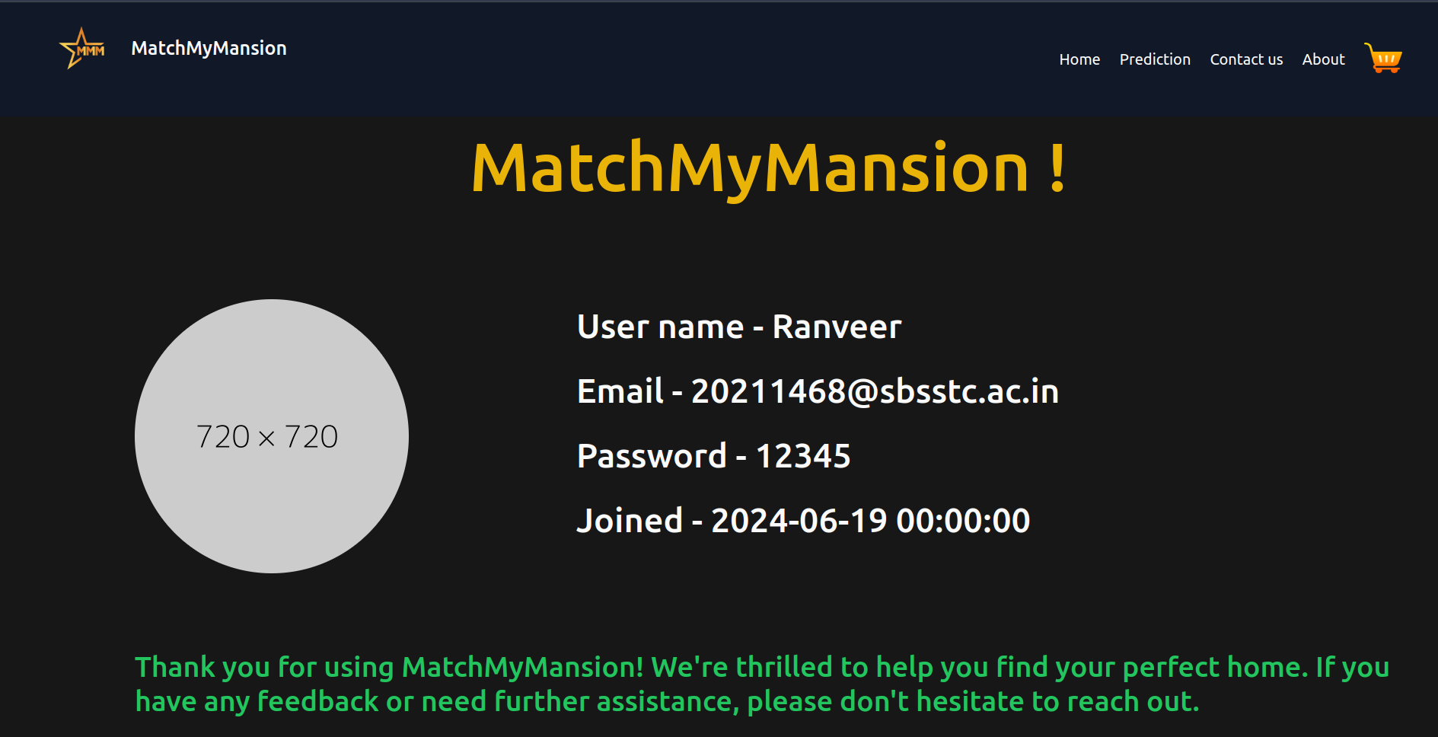4.2

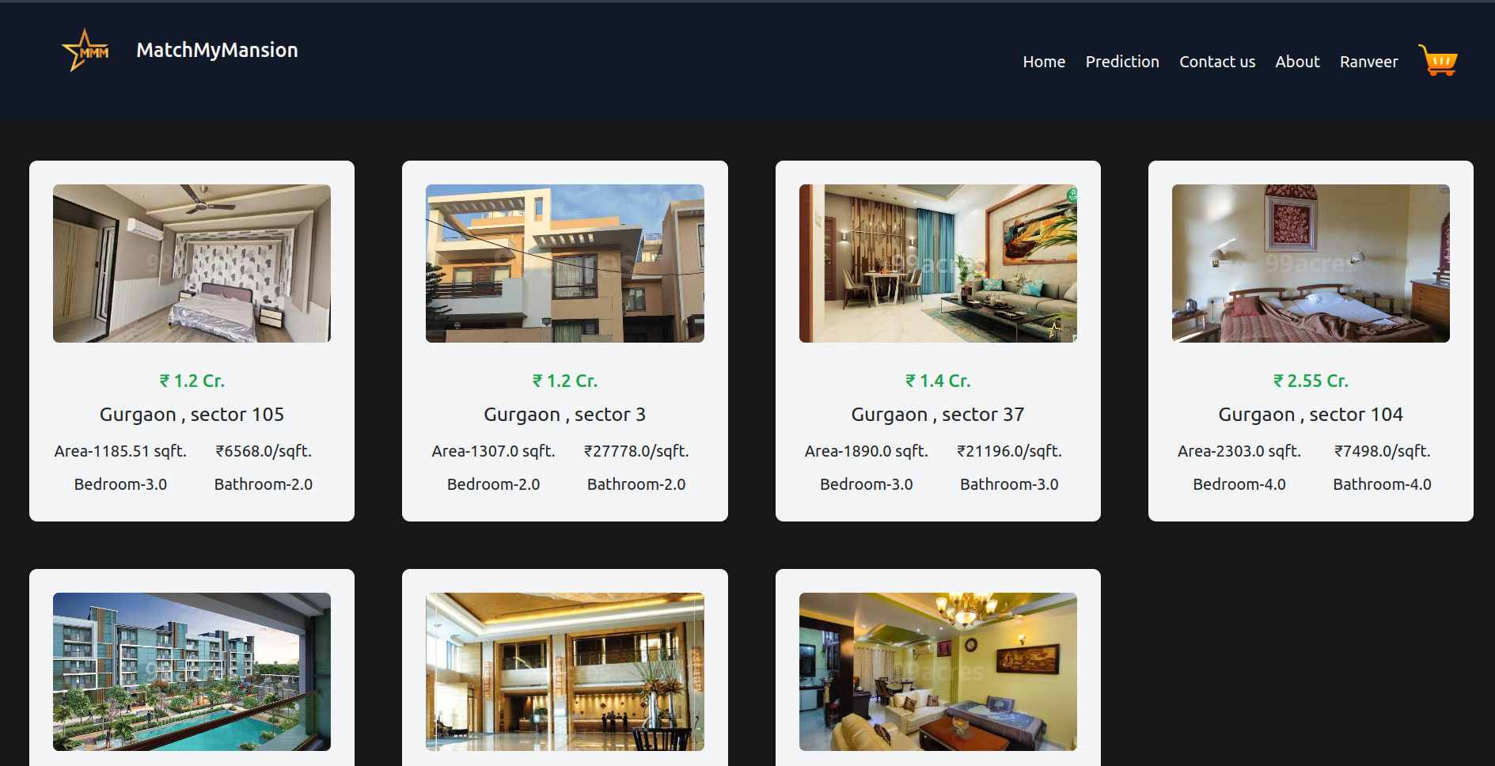

4.3

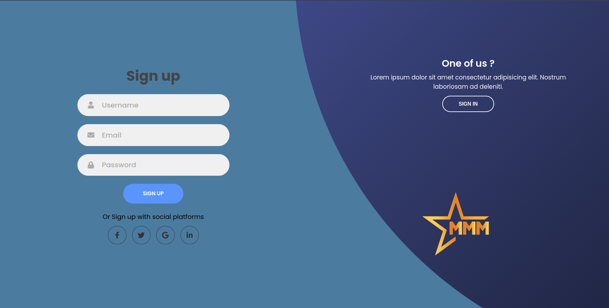4.4

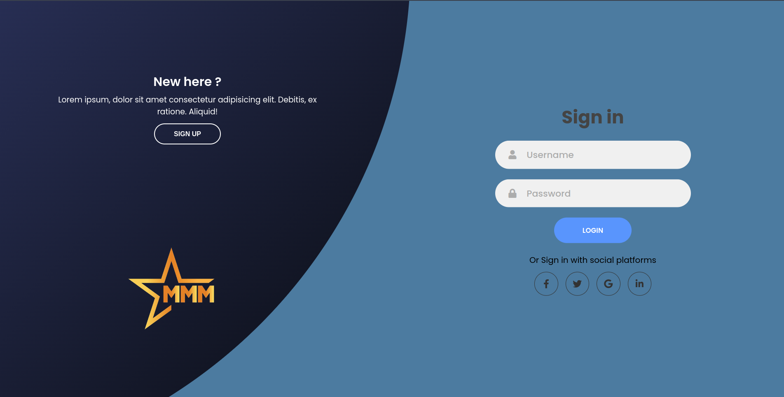

4.5

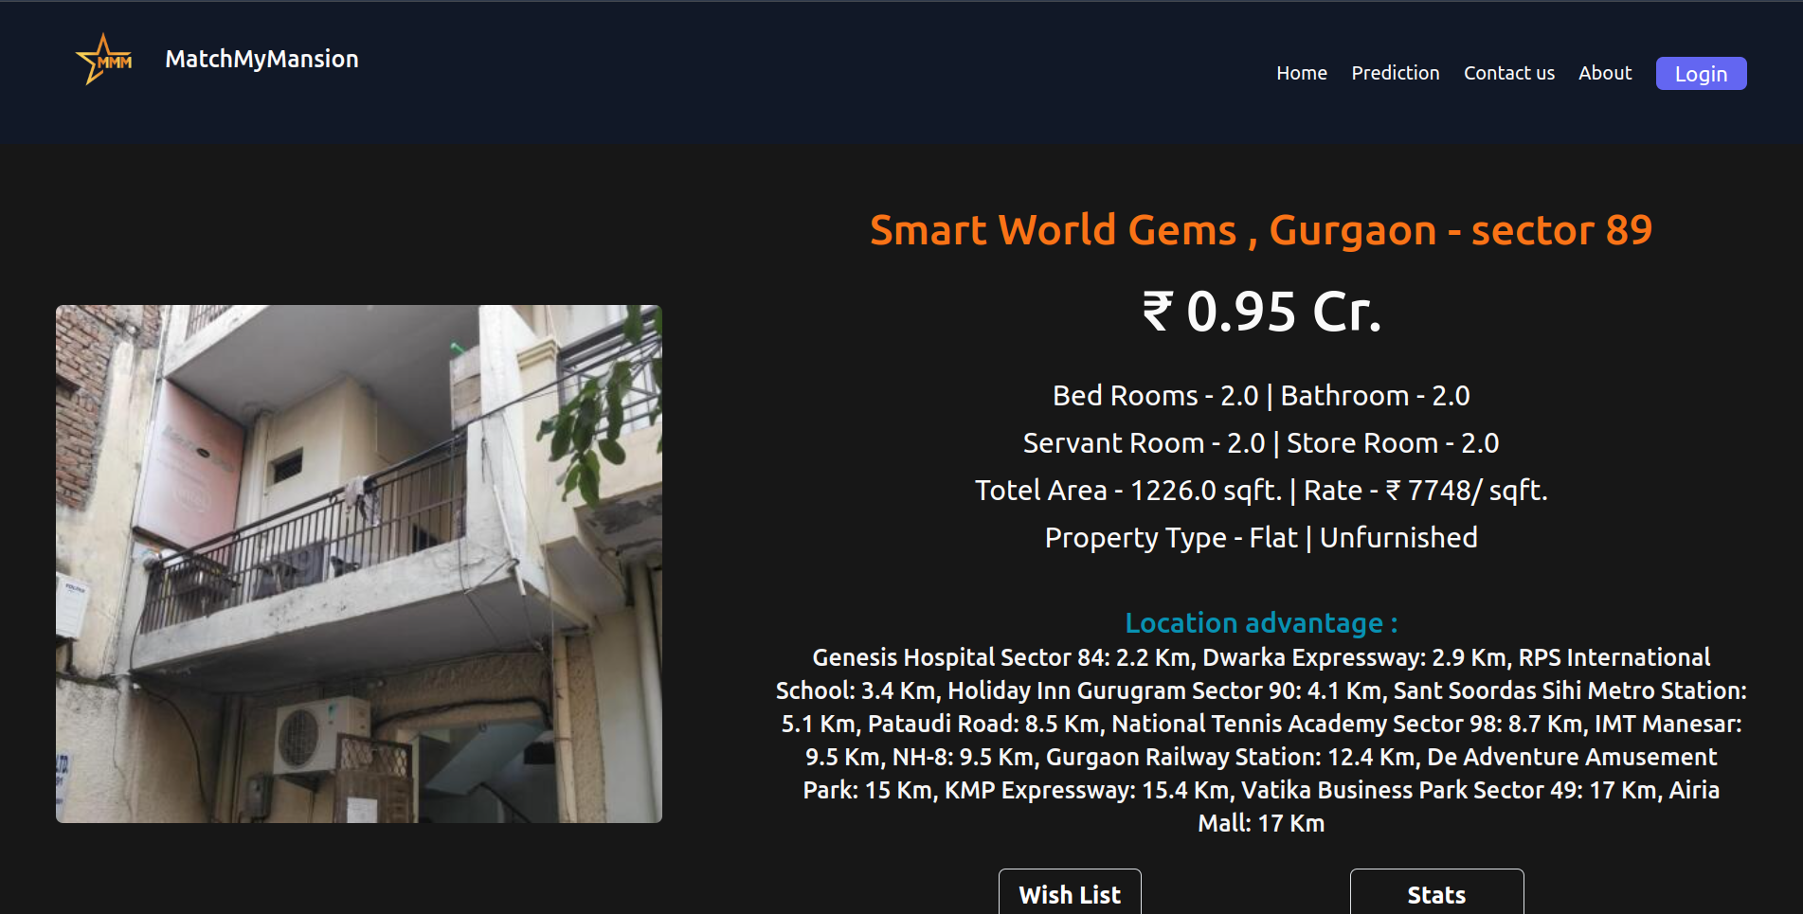4.6

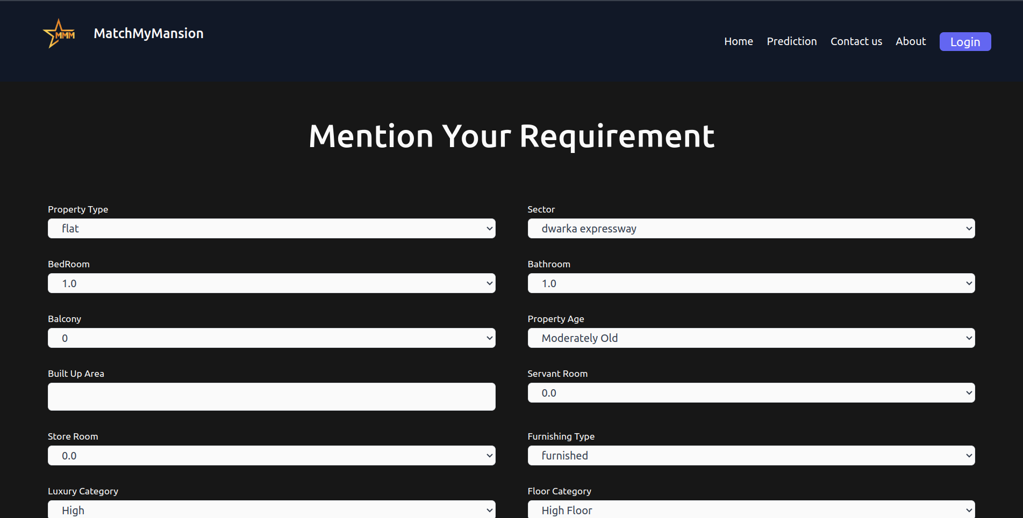

**Chapter 5: Overcomes of the Project**

Match My Mansion effectively addresses several key challenges in the real estate market:

1. Simplification of Property Search:
   * Challenge: Overwhelming number of property listings.
   * Solution: Curated recommendations based on user preferences, simplifying the search process.
2. Accurate Price Predictions:
   * Challenge: Wide variability in property prices.
   * Solution: Advanced regression models provide reliable price estimates considering various factors.
3. Personalized Recommendations:
   * Challenge: Lack of tailored property suggestions.
   * Solution: Combination of content-based and collaborative filtering techniques for personalized recommendations.
4. Enhanced User Experience:
   * Challenge: Time-consuming manual property search.
   * Solution: User-friendly web interface for efficient and enjoyable property search and recommendations.
5. Data-Driven Insights:
   * Challenge: Difficulty in extracting meaningful insights from large datasets.
   * Solution: Thorough data preprocessing, feature engineering, and exploratory data analysis for valuable insights.
6. Scalability and Real-Time Predictions:
   * Challenge: Resource-intensive handling of large data volumes.
   * Solution: Optimized system design for scalability and real-time performance.
7. User Trust and Confidence:
   * Challenge: Lack of trust in traditional property price predictions.
   * Solution: Accurate, machine learning-based predictions and transparent presentation of data build user trust.

By overcoming these challenges, Match My Mansion enhances the property search and recommendation process, making it more efficient, accurate, and user-centric.

**Chapter 6: Future Scope**

Match My Mansion has demonstrated significant potential in transforming the property search and recommendation process. There are several avenues for future enhancements and expansions that can further improve the system's accuracy, functionality, and user experience:

#### 1. **Incorporation of Additional Features**

* Crime Rates and Safety: Integrate crime statistics and safety ratings for neighborhoods to provide users with a comprehensive overview of the areas they are considering.
* School Ratings and Proximity: Include information about the quality and proximity of nearby schools, which can be a crucial factor for families.
* Public Transportation Accessibility: Add data on the accessibility and convenience of public transportation options, making the system more useful for users without personal vehicles.

#### 2. **Enhanced Machine Learning Models**

* Deep Learning Techniques: Explore the use of deep learning models, such as neural networks, for more accurate price predictions and recommendations.
* Time Series Analysis: Incorporate time series analysis to account for trends and seasonality in property prices, improving the prediction accuracy over time.
* User Behavior Analytics: Use advanced analytics to better understand user behavior and preferences, leading to more personalized recommendations.

#### 3. **Geographical Expansion**

* Broader Coverage: Expand the dataset to include properties from more geographical regions, both nationally and internationally, to cater to a wider audience.
* Localization and Language Support: Implement localization features and support for multiple languages to make the platform accessible to users from different regions and linguistic backgrounds.

#### 4. **User Interaction and Feedback Mechanisms**

* User Reviews and Ratings: Allow users to leave reviews and ratings for properties and neighborhoods, adding a social component to the platform and providing valuable insights for other users.
* Feedback Loops: Implement mechanisms for users to provide feedback on the recommendations and price predictions, which can be used to continuously improve the system.

#### 5. **Integration with Real Estate Platforms**

* API Integrations: Develop API integrations with popular real estate platforms to ensure real-time updates of property listings and seamless data flow.
* Partnerships with Real Estate Agents: Collaborate with real estate agents and agencies to offer users additional services, such as virtual tours, property visits, and consultation.

#### 6. **Advanced Visualization and Reporting**

* Interactive Maps: Enhance the user interface with interactive maps that display property locations, price heatmaps, and neighborhood amenities.
* Customized Reports: Provide users with detailed, customized reports on their property searches, including price trends, neighborhood statistics, and personalized recommendations.

#### 7. **Mobile Application Development**

* Mobile App: Develop a mobile application to complement the web interface, offering users a convenient way to search for properties and receive recommendations on the go.
* Push Notifications: Implement push notifications to alert users about new property listings, price changes, and personalized recommendations.

#### 8. **Security and Privacy Enhancements**

* Data Security: Continuously enhance data security measures to protect user information and ensure compliance with privacy regulations.
* User Privacy Controls: Provide users with more control over their data, including options to manage their preferences and privacy settings.

**Chapter 7: Conclusion**

Match My Mansion is a pioneering project that harnesses the power of machine learning to streamline and enhance the property search and recommendation process. By addressing key challenges in the real estate market, such as overwhelming listing volumes, price variability, and the need for personalized recommendations, the system offers a comprehensive solution that simplifies decision-making for users.The project successfully integrates advanced regression models and recommendation algorithms to deliver accurate price predictions and tailored property suggestions. The user-friendly web interface ensures a seamless and engaging experience, enabling users to efficiently find properties that meet their preferences and budget.

The potential for future enhancements is vast, including the incorporation of additional features like crime rates, school ratings, and public transportation accessibility. Expanding the geographical coverage, integrating with real estate platforms, and developing a mobile application are also promising directions. Advanced machine learning techniques, user behavior analytics, and interactive visualizations will further improve the system's accuracy and usability.

Match My Mansion exemplifies the transformative impact of machine learning in the real estate sector. It provides users with data-driven insights and personalized recommendations, empowering them to make informed property decisions with confidence. As the project evolves, it aims to become an indispensable resource for property seekers, continually adapting to meet their needs and preferences.